Supplementary Data

Table S1: Drug likeness prediction using pkCSM online database server for all the selected ligands
Ligands | Molecular weight < 500 (g/mol) | H-bond acceptor < 10 | H-bond donors < 5 | log P < 5
Ilicol | 238.371 | 2 | 2 | 2.8924
Eucalyptone | 486.605 | 7 | 3 | 5.1849
Ascleposide E | 388.457 | 8 | 4 | -0.2541

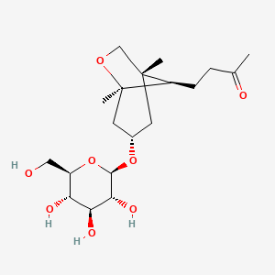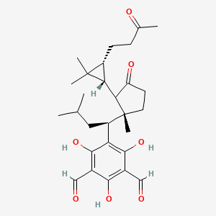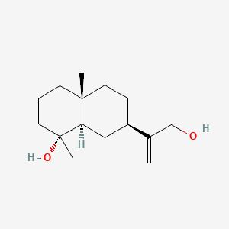
Eucalyptone
Ilicol
Ascleposide E
Figure S1: Chemical structure of selected SLs

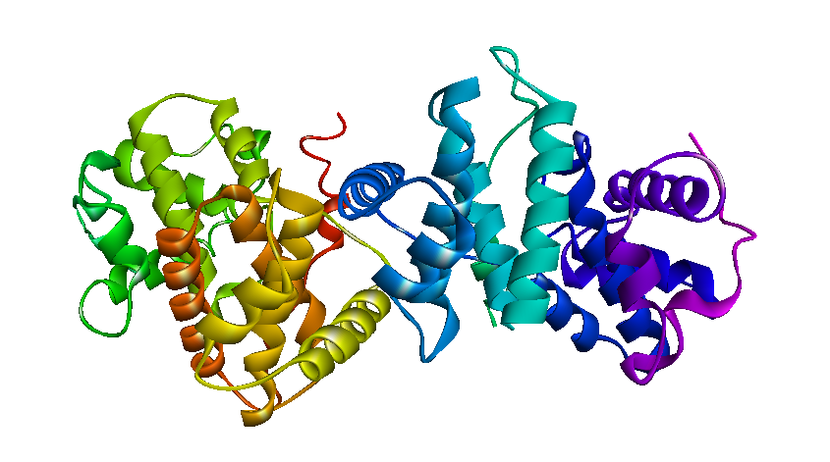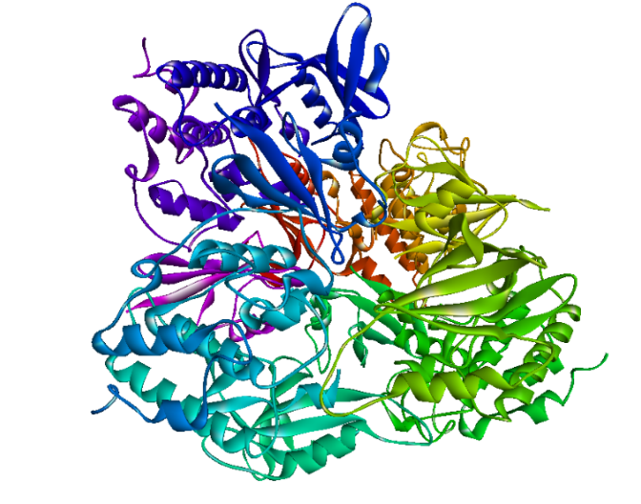
a
b

Figure S2: Crystal structure of CB1 (a) and CDK1 (b) of G2/M phase checkpoints

