Supplementary Figure S1. Crystal structure of SARS-CoV-2 3CL-Pro bound with the native ligand N3 (PDB ID: 6LU7)

Supplementary Figure S2. Two dimensional and three dimensional interactions of selected C. citratus compounds with 6LU7, along with the name and position of interacting amino acids, type of bond, calculated distances and energies.
2D Interactions | Amino acids | Type | Distance | Energy | 3D Interactions

Tannic acid
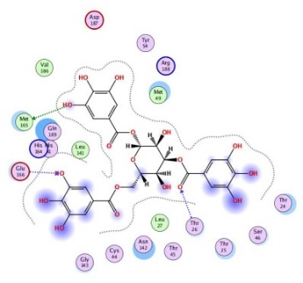 | MET165 | H-donor | 4.05 | -1.0
 | GLU166 | H-acceptor | 3.02 | -1.2
 | THR26 | H-acceptor | 3.06 | -1.6

Swertiajaponin
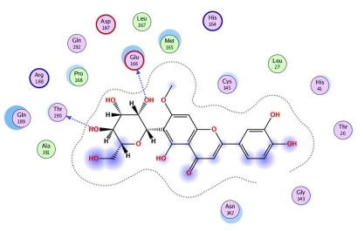 | THR 190 | H-donor | 2.84 | -1.1
 | GLU 166 | H-donor | 2.62 | -1.4

Chlorogenic acid
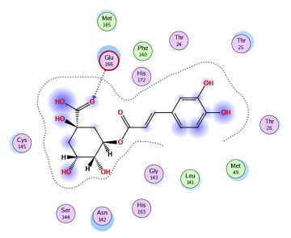 | GLU 166 | H-acceptor | 3.01 | -1.8 | 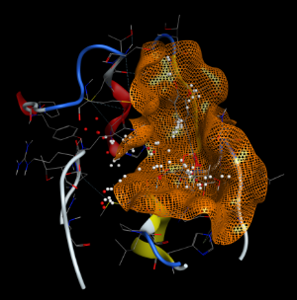

Cymbopogonol
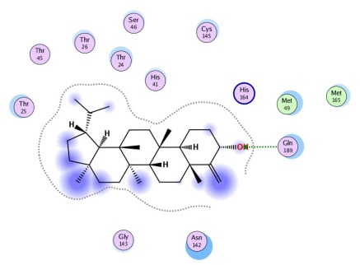 | GLN 189 | H-acceptor | 3.03 | -2.1

Warfarin
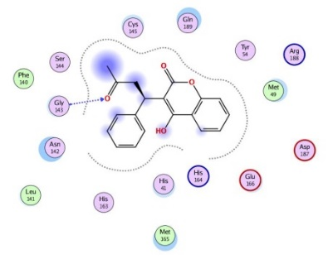 | GLY 143 | H-acceptor | 3.10 | -1.8

Citral diethyl acetal
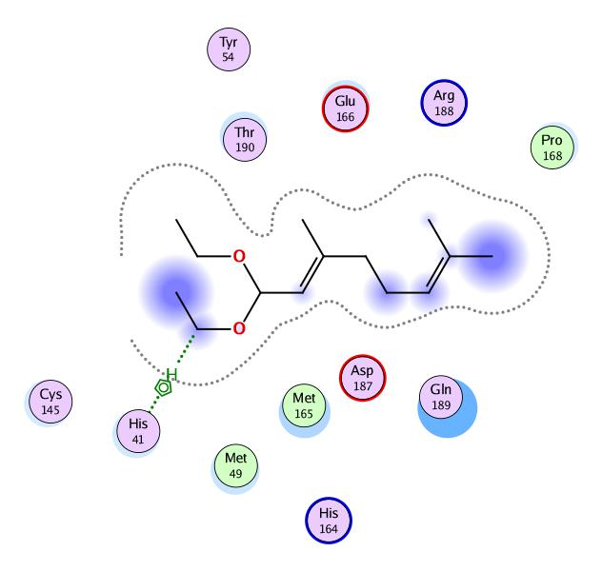 | HIS 41 | H-pi | 4.32 | -1.1

Citral acetate
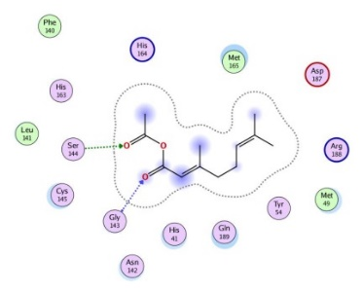 | GLY 143 | H-acceptor | 2.95 | -3.6
 | SER 144 | H-acceptor | 2.96 | -1.3

Luteolin
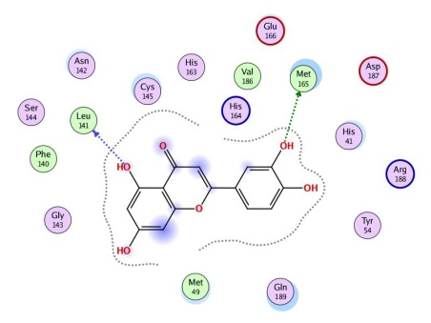 | LEU 141 | H-donor | 3.05 | -1.1
 | MET 165 | H-donor | 3.61 | -1.8

Kaempferol
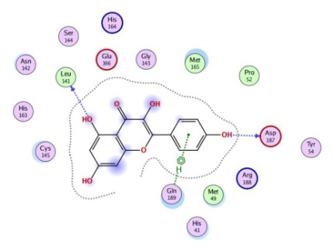 | LEU 141 | H-donor | 3.18 | -1.0
 | ASP 187 | H-donor | 2.91 | -1.1
 | GLN 189 | pi-H | 4.17 | -0.7

Cianidanol
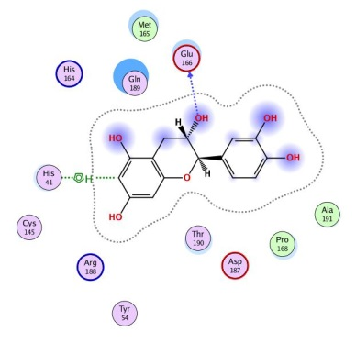 | GLU 166 | H-donor | 3.23 | -1.2
 | HIS 41 | H-pi | 3.92 | -1.5

